**Figure S1**. Relative age groups of the analysed specimens of *Agricola agrestis*: (A) ZIN 16897; (B) ZIN 89132; (C) ZIN 97312; (D) 98482.

Skulls are shown in lateral (top) and dorsal (bottom) view. Scale bars are 5 mm; skulls are shown at the same scale. *Key*: **a**, the temporal line in the adult specimen.

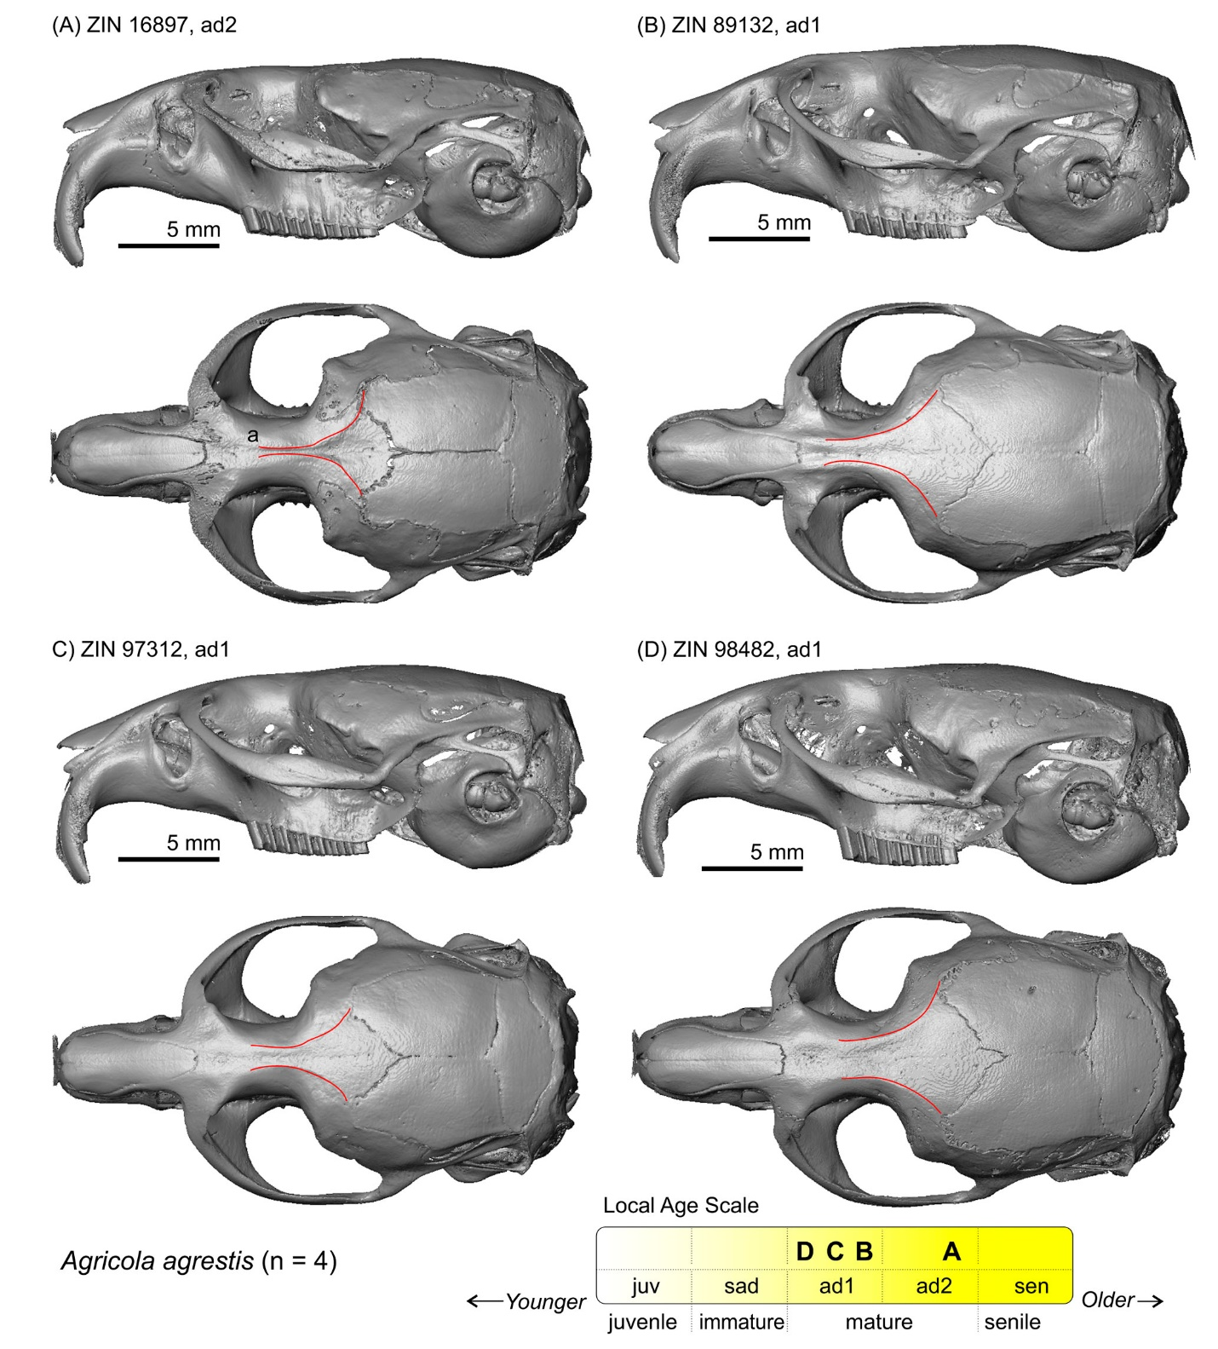

**Figure S2**. Relative age groups of the analysed specimens of *Alexandromys fortis*: (A) ZIN 83881; (B) ZIN 105505.

Skulls are shown in lateral (top) and dorsal (bottom) views. Scale bars are 5 mm; skulls are shown at the same scale. *Key*: **a**, the temporal line; **b**, line marks the profile of the zygomatic arch in a mature specimen compared to an immature specimen.

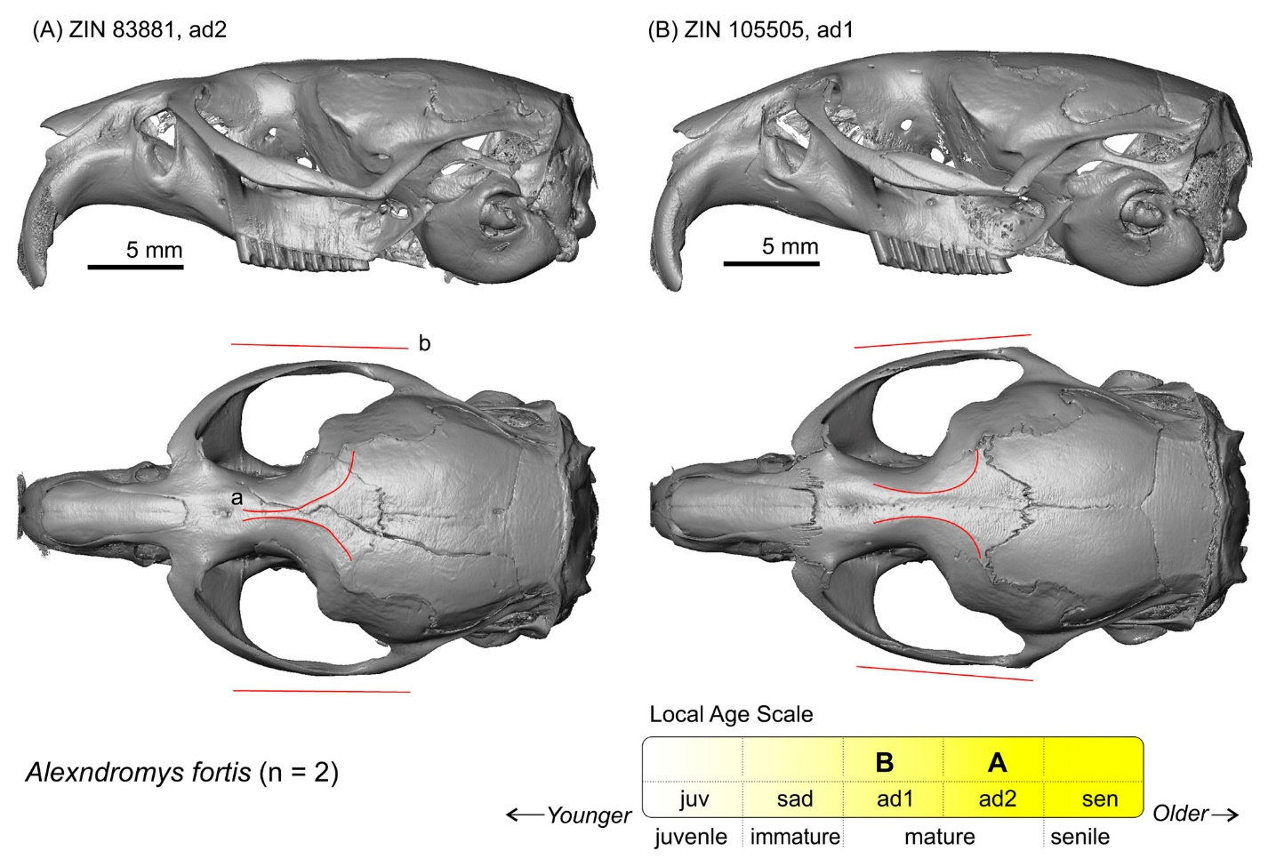

**Figure S3**. Screenshots of the PSP complex in subposterior view of specimen ZIN 101018 of *Alexandromys middendorffii* with landmark positions (left).

Skull in lateral (top, right) and dorsal (bottom, right) view. Scale bar is 5 mm.

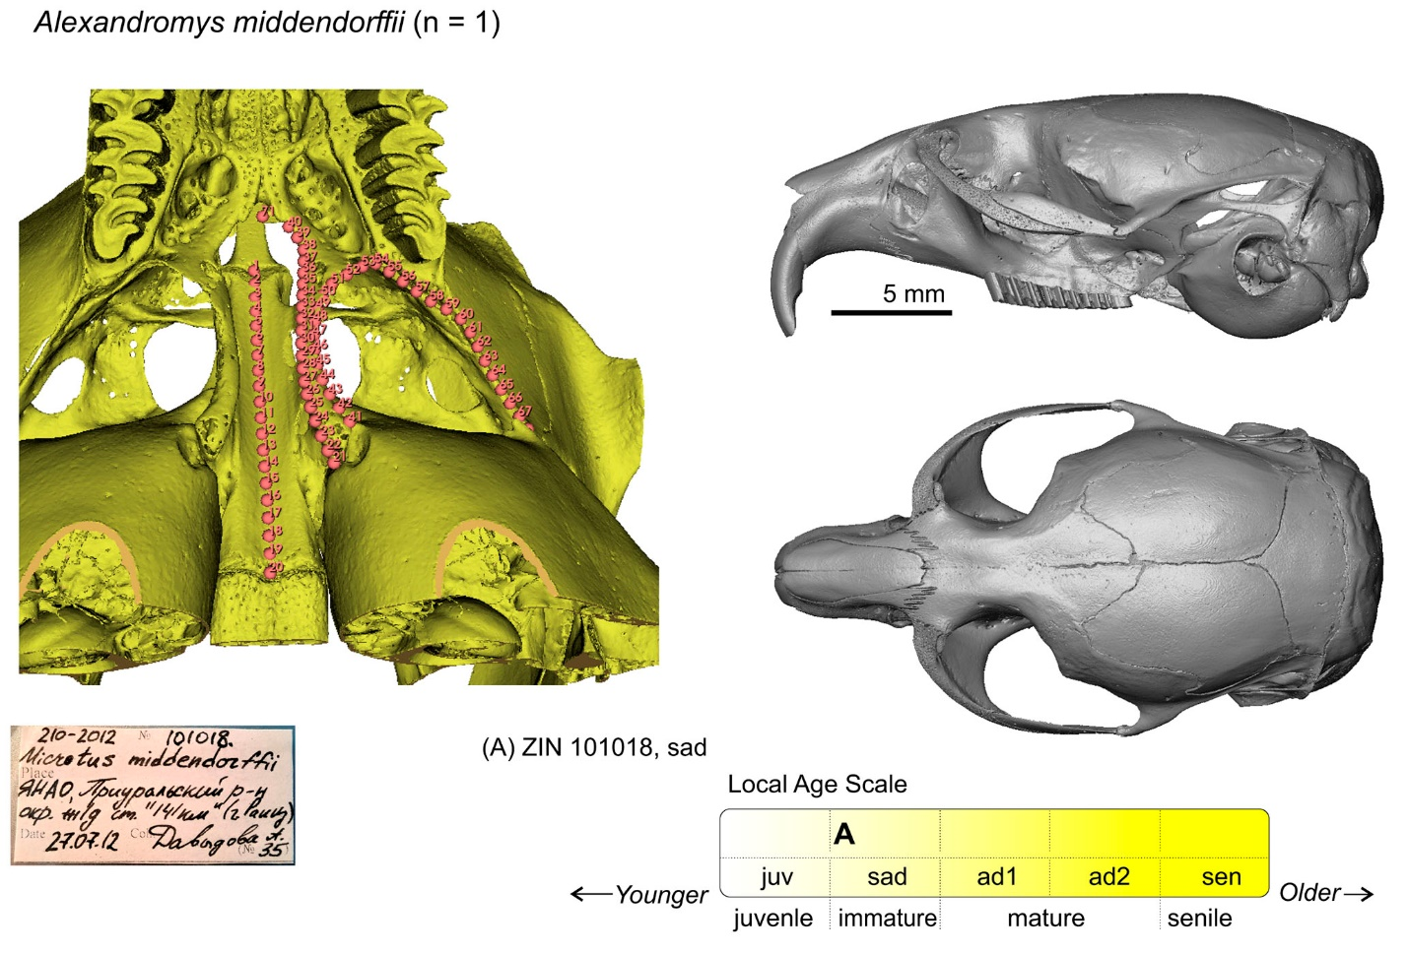

**Figure S4**. Relative age groups of the analysed specimens of *Alexandromys oeconomus*: (A) ZIN 66013; (B) ZIN 89161; (C) ZIN 96546; (D) ZIN 98883; (E) ZIN 100612; (F) ZIN 101023.

Skulls are shown in lateral (top) and dorsal (bottom) views. Scale bars are 5 mm; skulls are shown at the same scale. *Key*: **a**, line with arrow 'a1' marks differences between mature and immature specimens; **b**, temporal line.

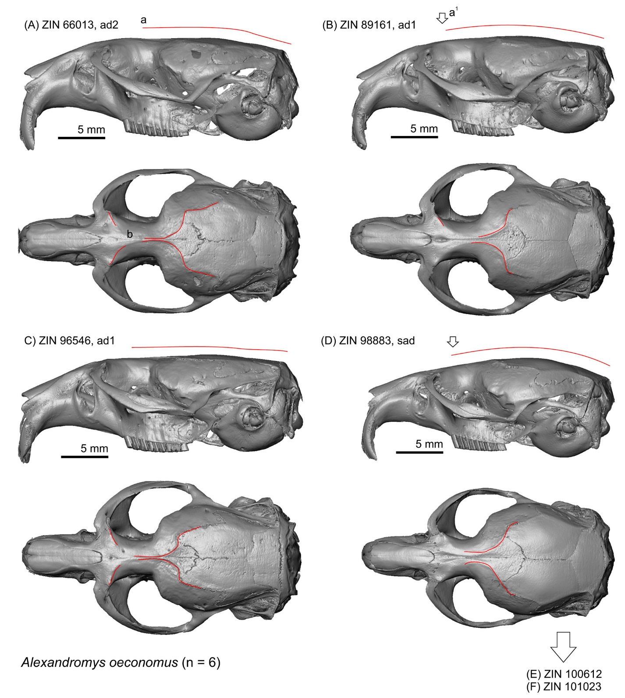

**Figure S4**. Continue.

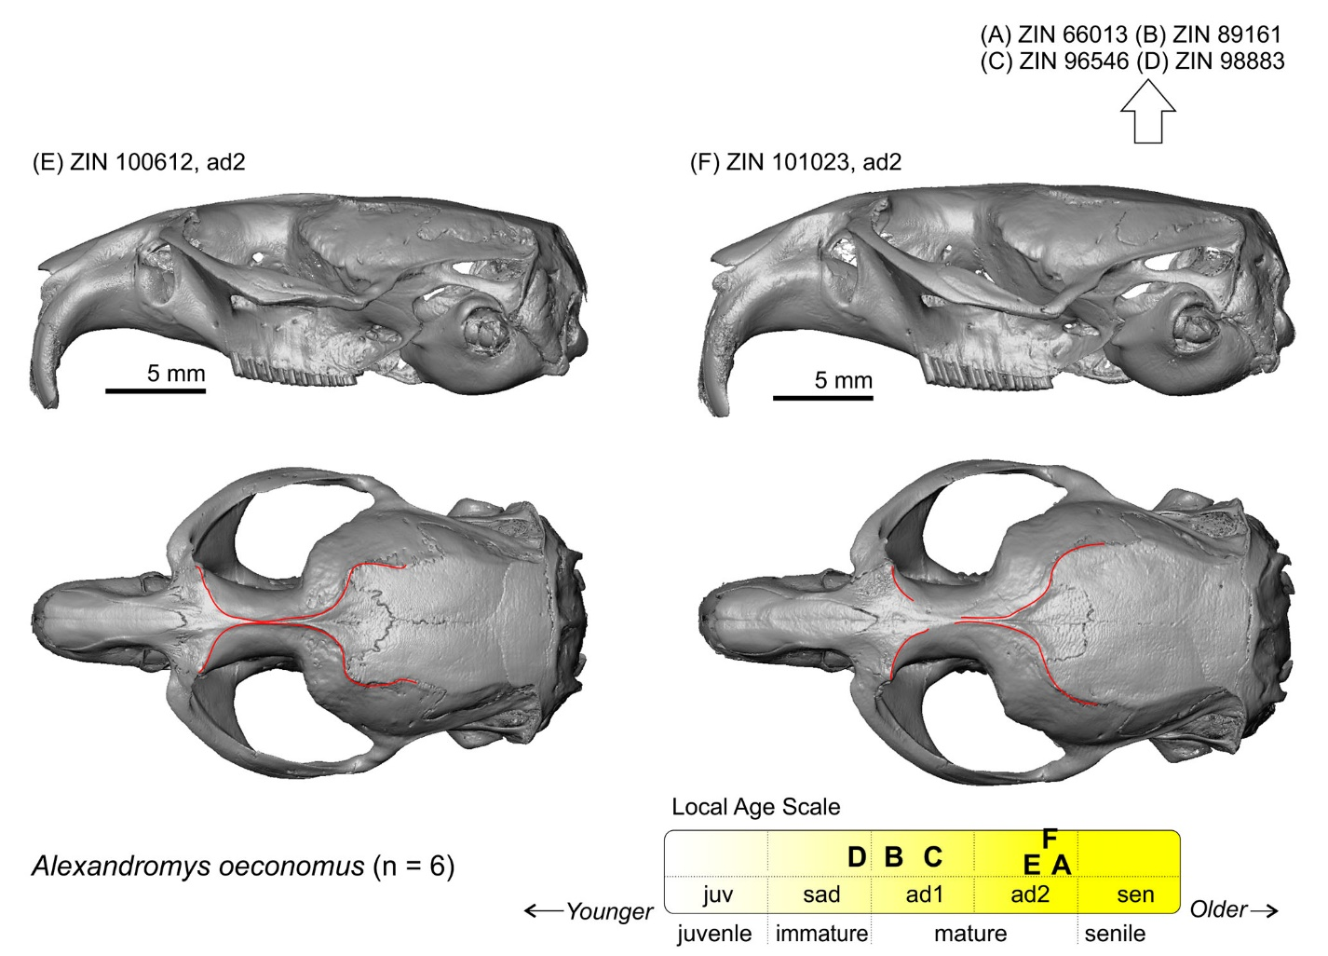

**Figure S5**. Relative age groups of the analysed specimens of *Alticola argentatus*: (A) ZIN 77405; (B) ZIN 77458; (C) ZIN 77464; (D) 77489.

Skulls are shown in lateral (top) and dorsal (bottom) view. Scale bars are 5 mm; skulls are shown at the same scale. *Key*: **a,** line together with arrow 'b' marks differences between mature and immature specimens; **b**, arrow marks condylar position in mature vs immature specimen; **c**, line marks the profile of the zygomatic arch in a mature specimen compared to an immature specimen; **d**, temporal line in mature specimen.

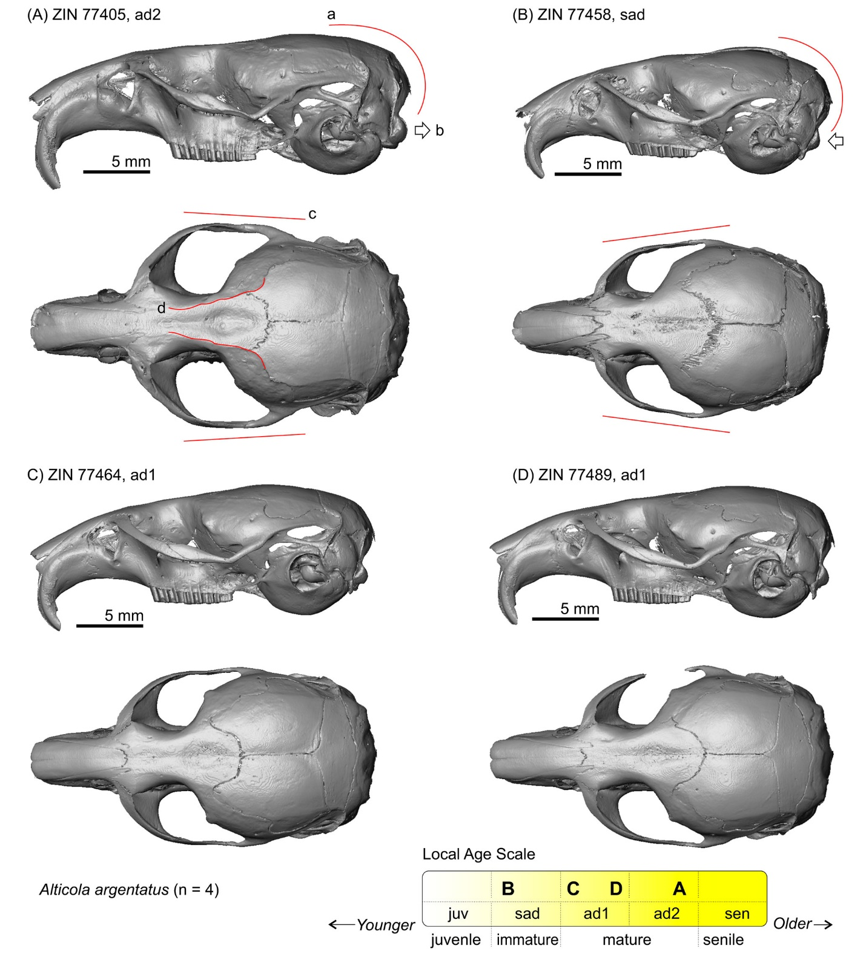

**Figure S6**. Relative age groups of the analysed specimens of *Alticola lemminus*: (A) ZIN 101796; (B) ZIN 101797.

Skulls are shown in lateral (top) and dorsal (bottom) views. Scale bars are 5 mm; skulls are shown at the same scale. The age group was determined with the aid of *A. argentatus* age attribution (see Fig. S5).

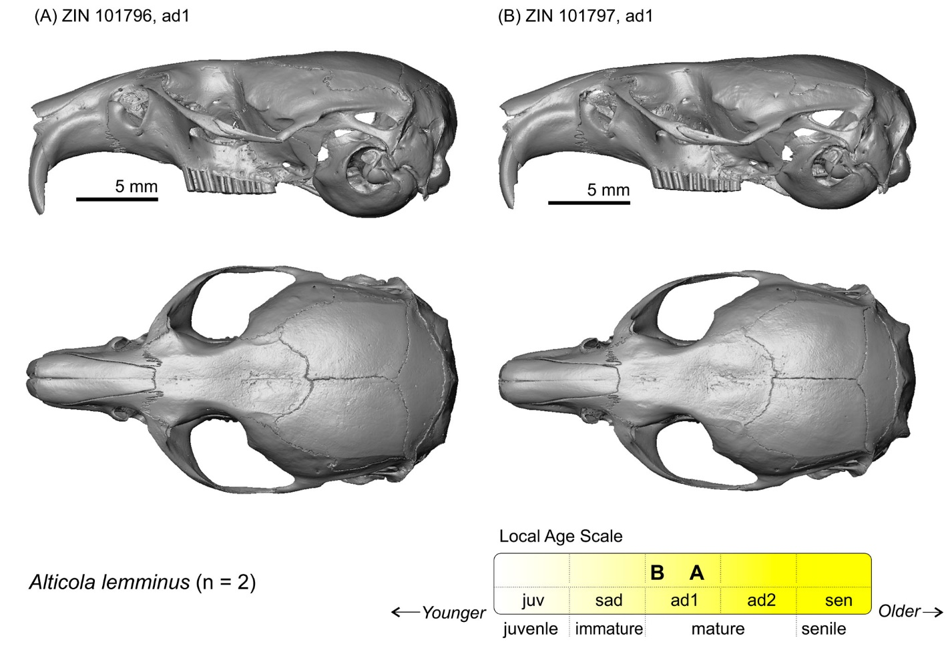

**Figure S7**. Relative age groups of the analysed specimens of *Alticola macrotis*: (A) ZIN 102289; (B) ZIN 102307; (C) ZIN 99351.

Skulls are shown in lateral (top) and dorsal (bottom) views. Scale bars are 5 mm; skulls are shown at the same scale. The age group was determined with the aid of *A. argentatus* age attribution (see Fig. S5).

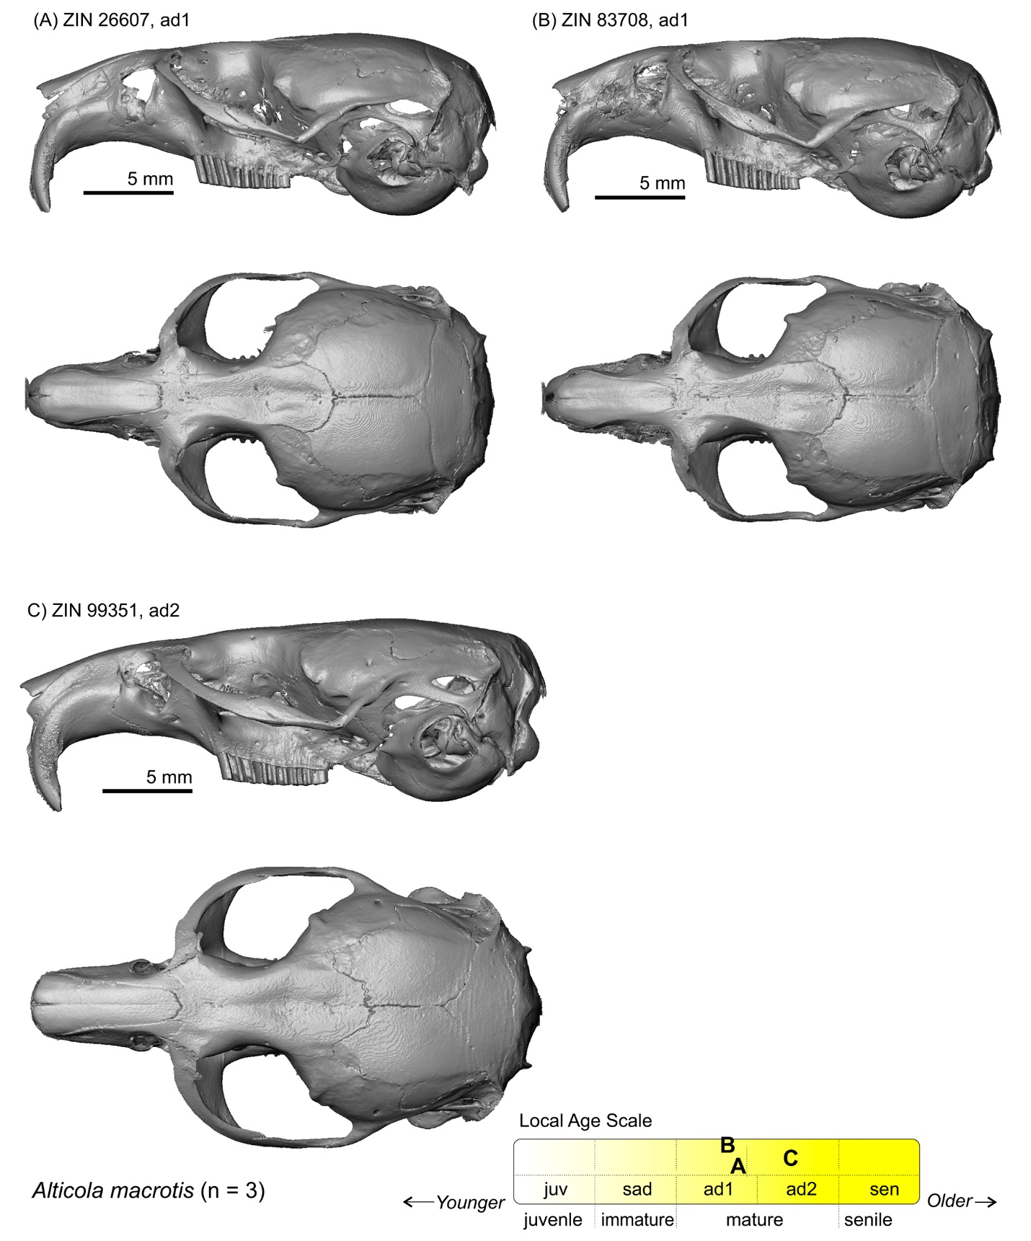

**Figure S8**. Relative age groups of the analysed specimens of *Alticola semicanus*: (A) ZIN 107067; (B) ZIN 107068.

Skulls are shown in lateral (top) and dorsal (bottom) views. Scale bars are 5 mm; skulls are shown at the same scale. The age group was determined with the aid of *A. argentatus* age attribution (see Fig. S5).

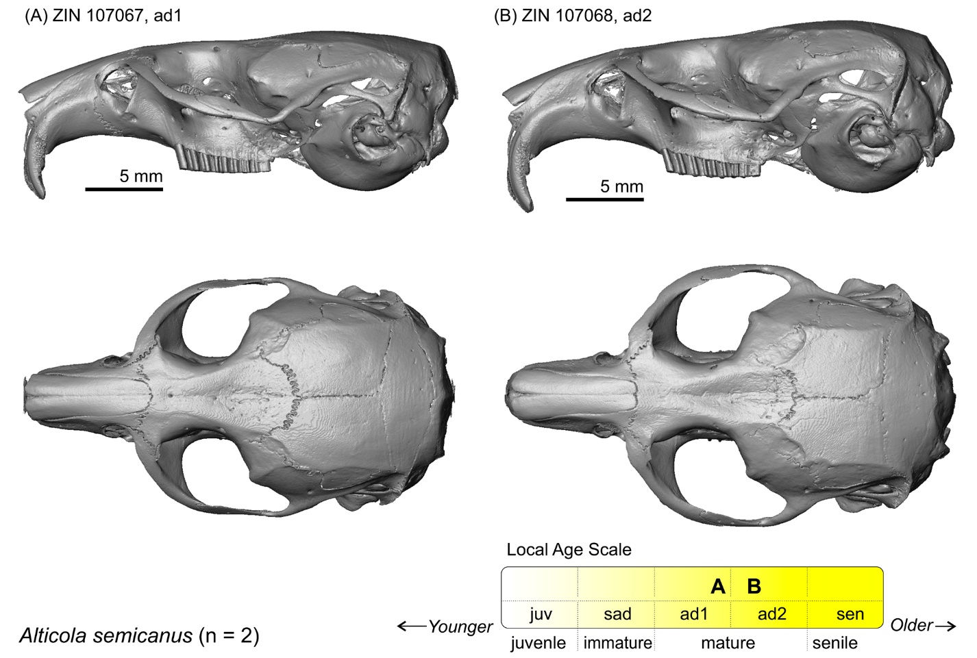

**Figure S9**. Relative age groups of the analysed specimens of *Arvicola* *amphibius*: (A) ZIN 10034; (B) ZIN 16365; (C) ZIN 45399.

Skulls are shown in lateral (top) and dorsal (bottom) views. Scale bars are 5 mm; skulls are shown at the same scale. *Key*: **a**, temporal line.

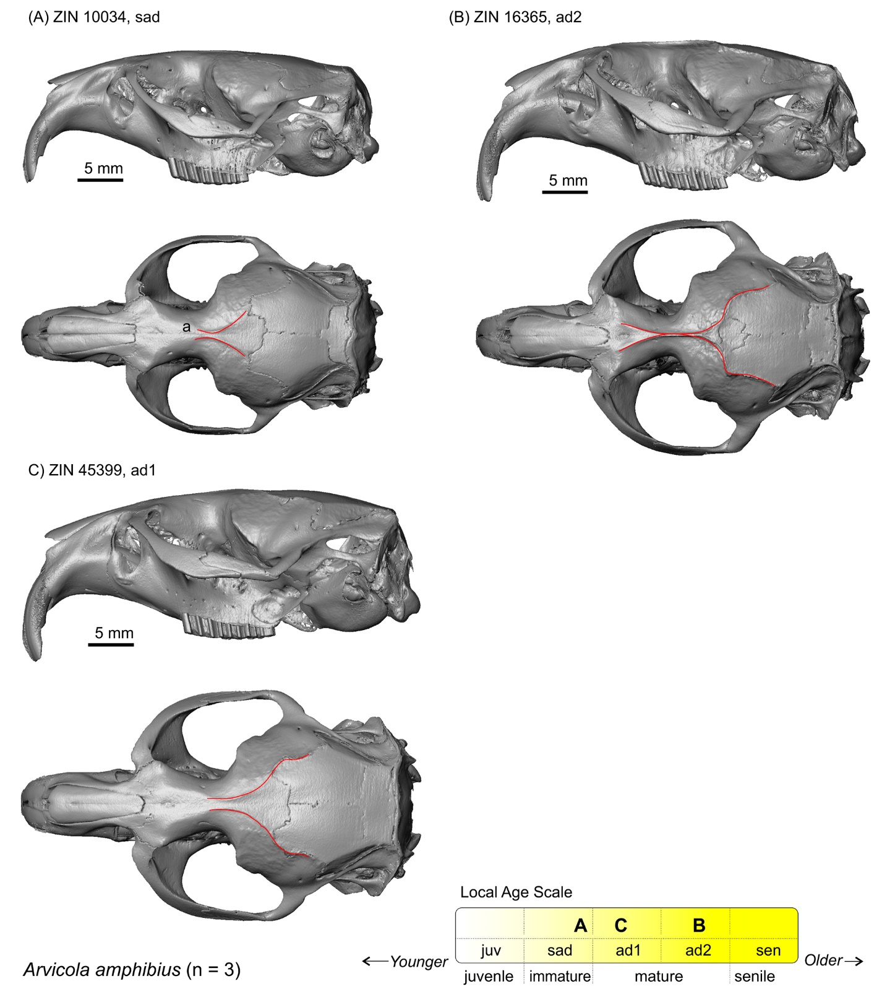

**Figure S10**. Relative age groups of the analysed specimens of *Chionomys nivalis*: (A) ZIN 70703; (B) ZIN 71279; (C) ZIN 106369.

Skulls are shown in lateral (top) and dorsal (bottom) views. Scale bars are 5 mm; skulls are shown at the same scale. *Key*: **a**, temporal line.

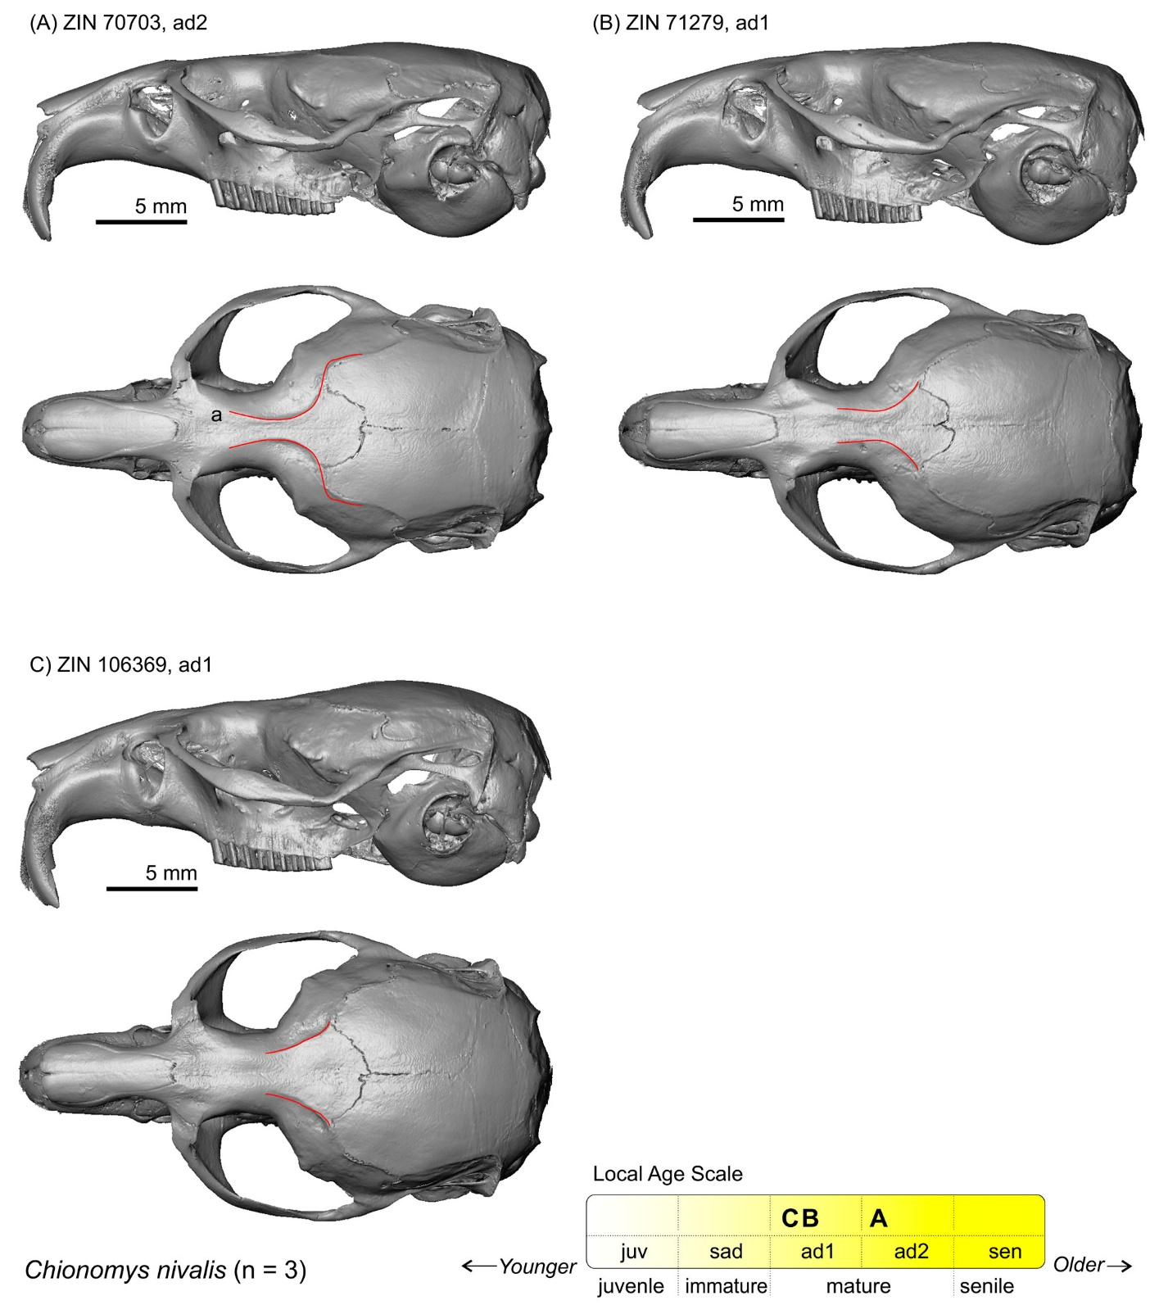

**Figure S11**. Screenshots of the PSP complex in subposterior view of specimen ZIN 102929 of *Craseomys rufocanus* with landmark positions (left). Skull in lateral (top, right) and dorsal (bottom, right) view.

The lower image shows lateral radiograph of molar roots (root-bearing species only). Scale bar is 5 mm.

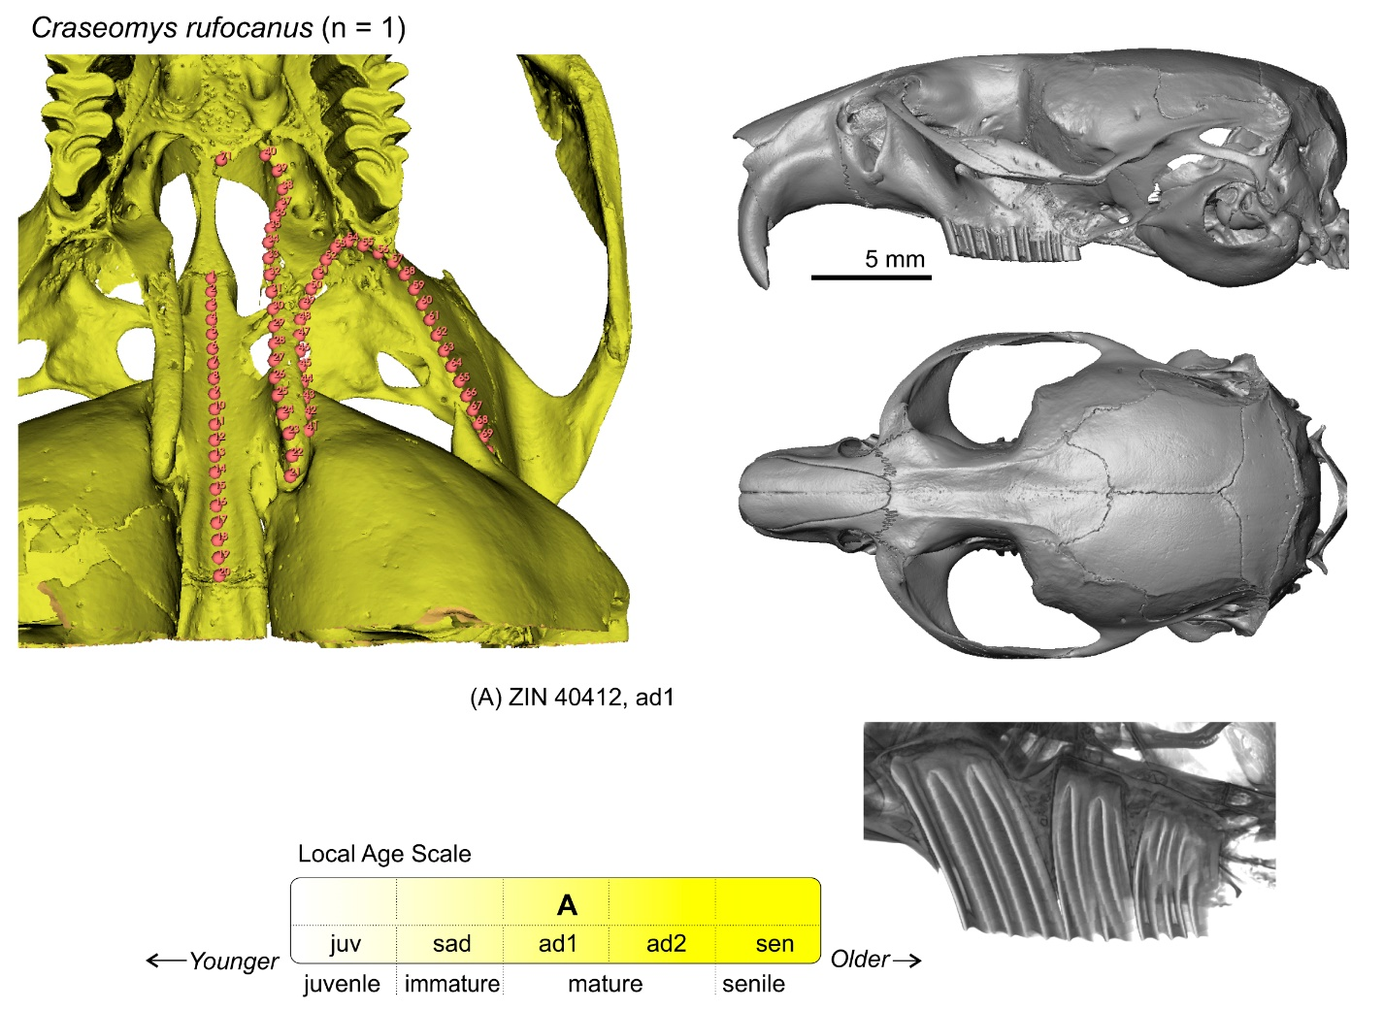

**Figure S12**. Relative age groups of the analysed specimens of *Dicrostonyx torquatus*: (A) ZIN 81169; (B) ZIN 81254; (C) ZIN 81552.

Skulls are shown in lateral (top) and dorsal (bottom) views. Scale bars are 5 mm; skulls are shown at the same scale. The age group was determined with the aid of *L. sibiricus* age attribution (see Fig. S21 below). *Key*: **a**, temporal line; **b**, nuchal crest.

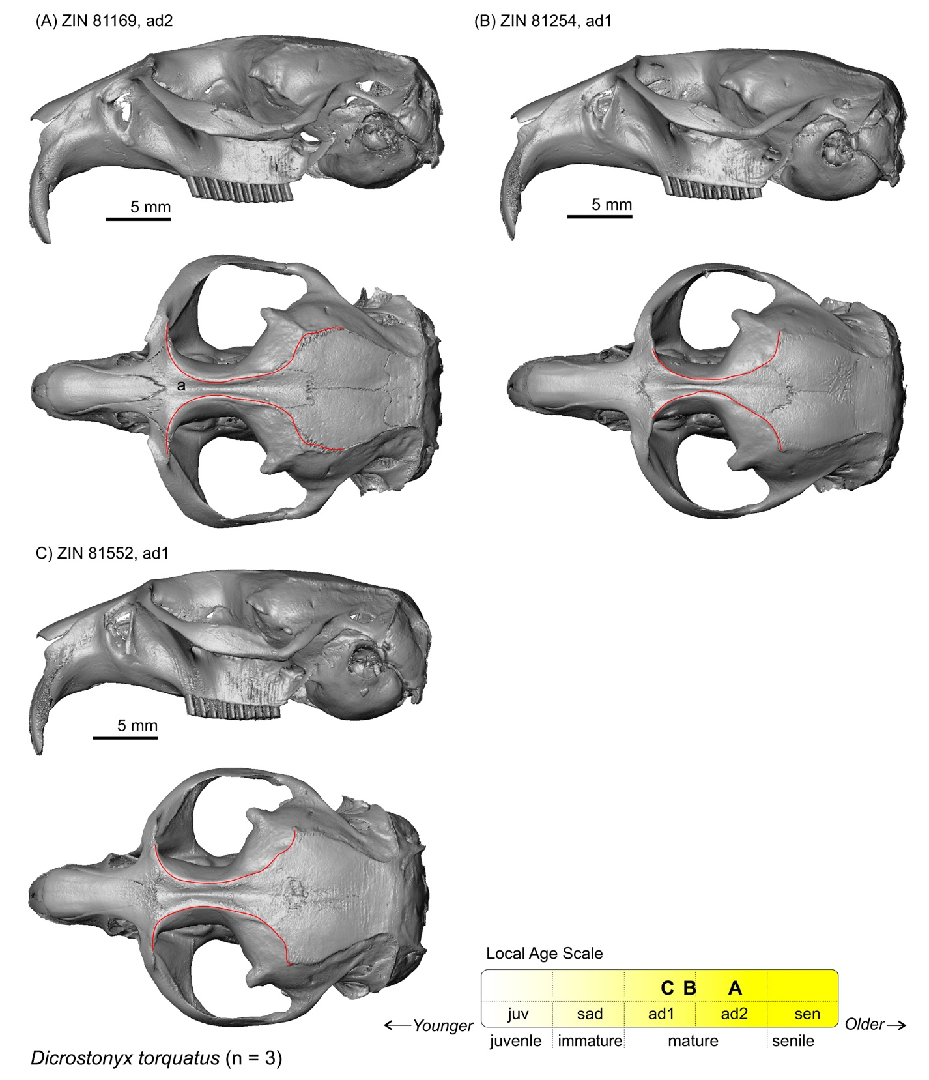

**Figure S13**. Relative age groups of the analysed specimens of *Dinaromys bogdanovi*: (A) ZIN 34835; (B) ZIN 34887.

Skulls are shown in lateral (top) and dorsal (middle) views. The lower images show lateral radiographs of molar roots (root-bearing species only). Scale bars are 5 mm; skulls are shown at the same scale. *Key*: **a**, the temporal line.

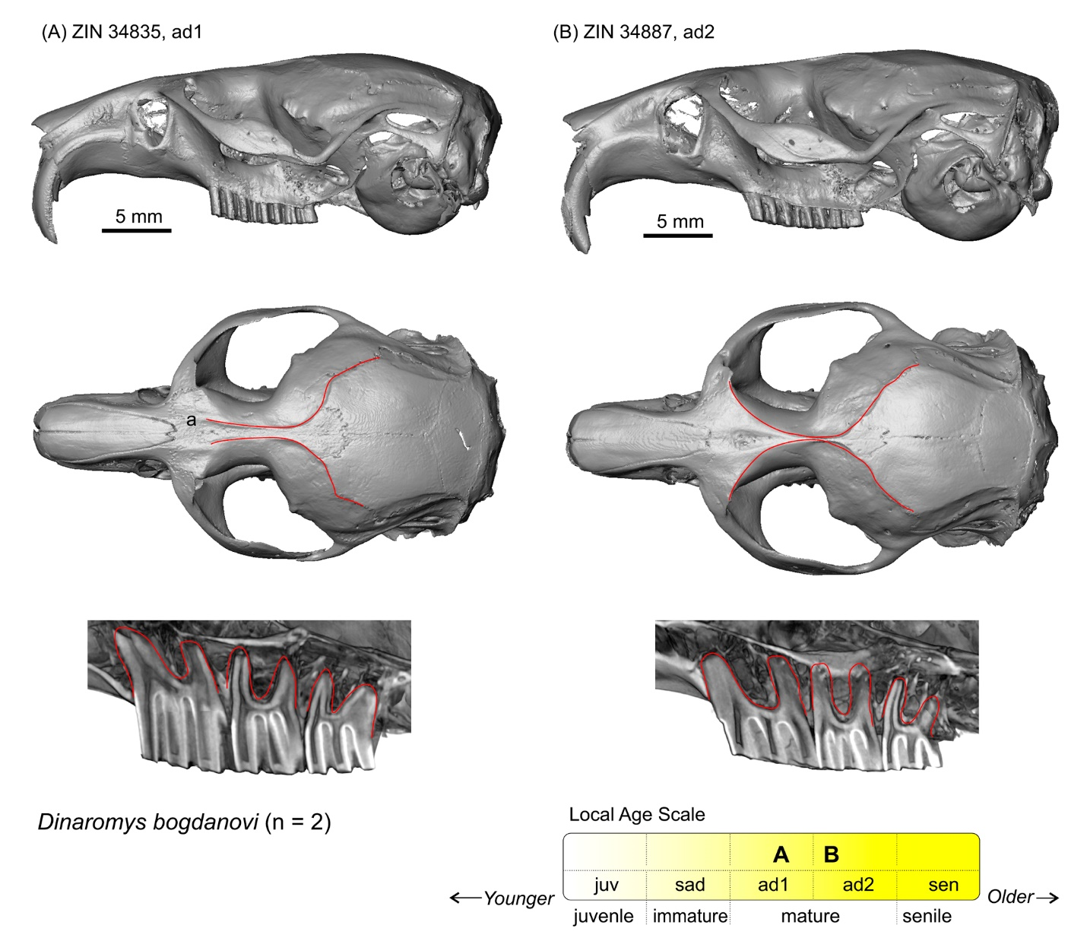

**Figure S14**. Relative age groups of the analysed specimens of *Ellobius lutescens*: (A) ZIN 26607; (B) ZIN 83708; (C) ZIN 85284; (D) ZIN 85287.

Skulls are shown in lateral (top) and dorsal (bottom) views. (E1–E4) Lateral radiographs of molar roots (root-bearing species only). Scale bars are 5 mm; skulls are shown at the same scale. *Key*: **a**, temporal line.

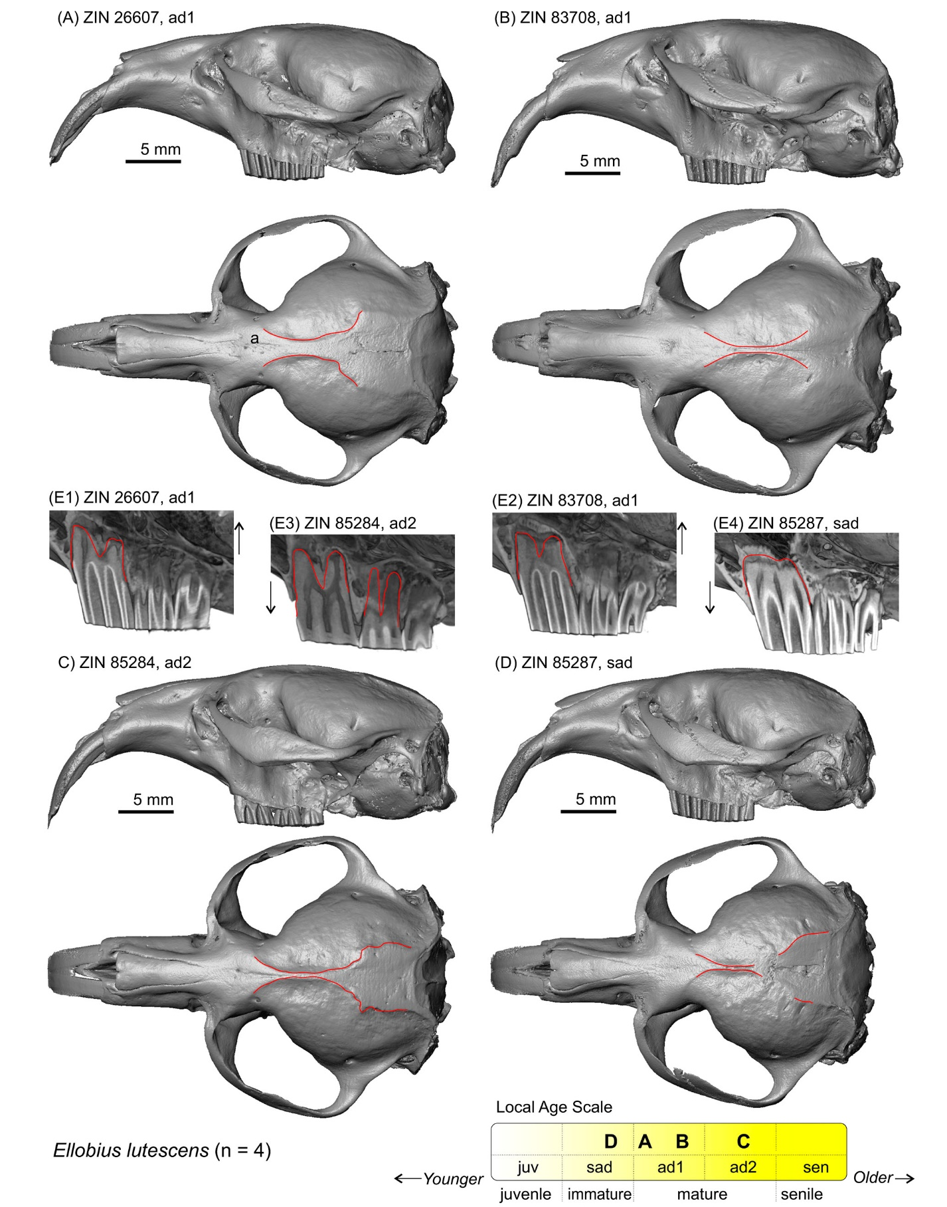

**Figure S15**. Relative age groups of the analysed specimens of *Ellobius talpinus*: (A) ZIN 11763; (B) ZIN 35828; (C) ZIN 82955; (D) ZIN 84395; (F) ZIN 102342.

(E1–E5) Lateral radiographs of molar roots (root-bearing species only). Skulls are shown in lateral (top) and dorsal (bottom) views. Scale bars are 5 mm; skulls are shown at the same scale. The age group was determined with the aid of *E. lutescens* age attribution (see Fig. S14). *Key*: **a**, temporal line; **b**, nuchal crest.

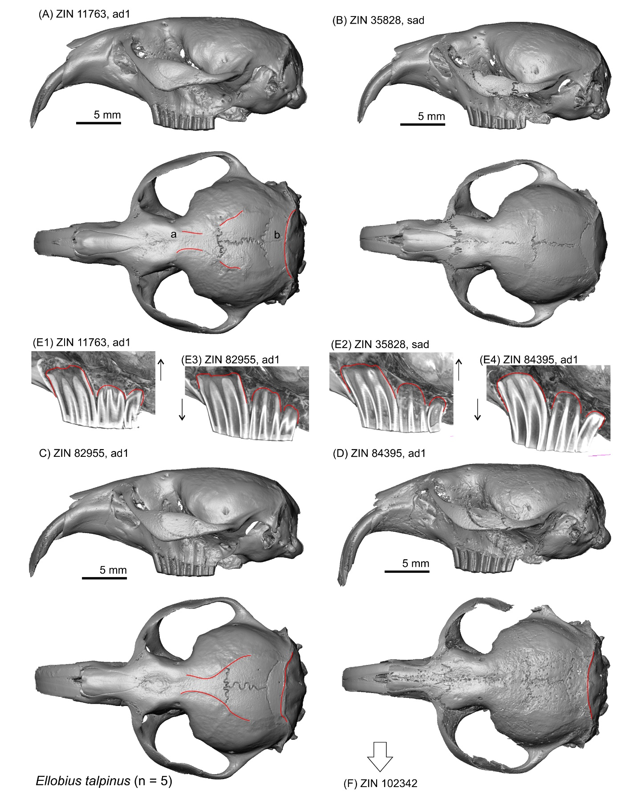

**Figure S15**. Continue.

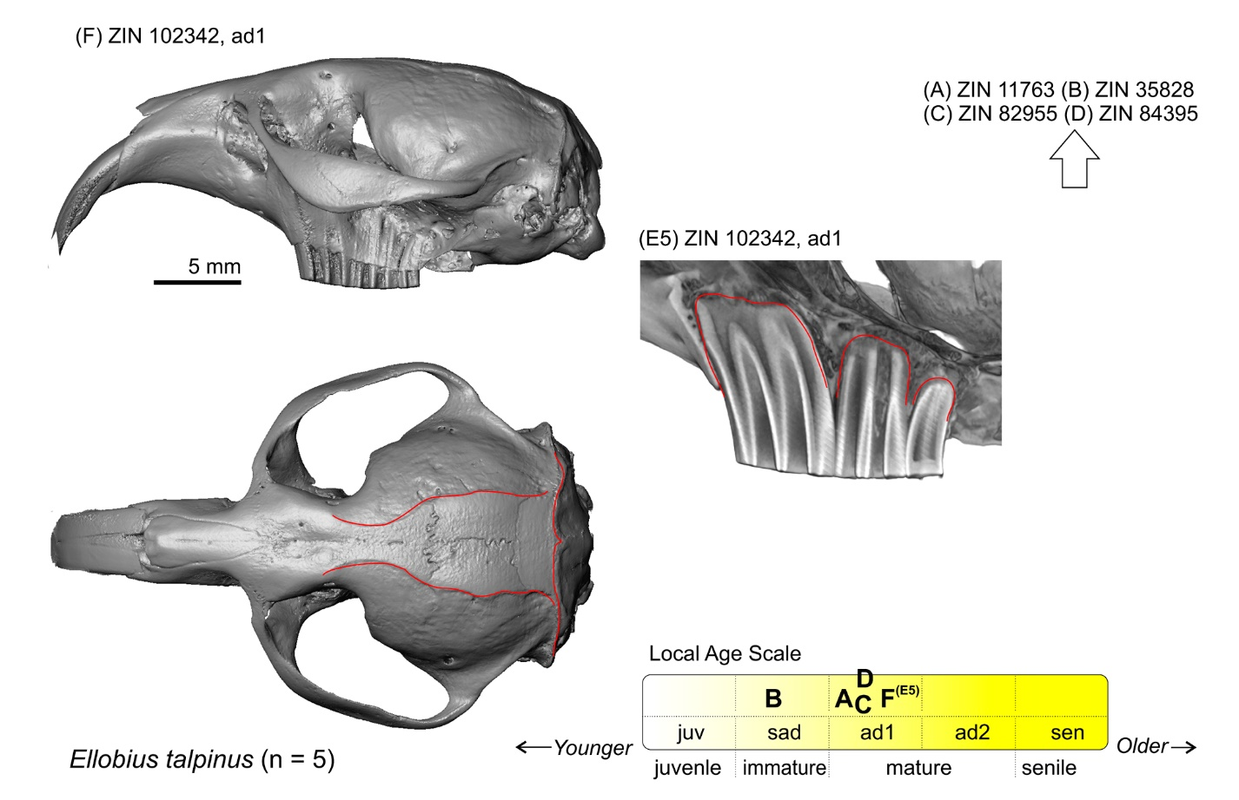

**Figure S16**. Relative age groups of the analysed specimens of *Lagurus lagurus*: (A) ZIN 29170; (B) ZIN 57188.

Skulls are shown in lateral (top) and dorsal (bottom) views. Scale bars are 5 mm; skulls are shown at the same scale. *Key*: **a**, frame with arrow 'a1' marks differences in relative position of teeth and tympanic bulla levels between mature and immature specimens; **b**, temporal line.

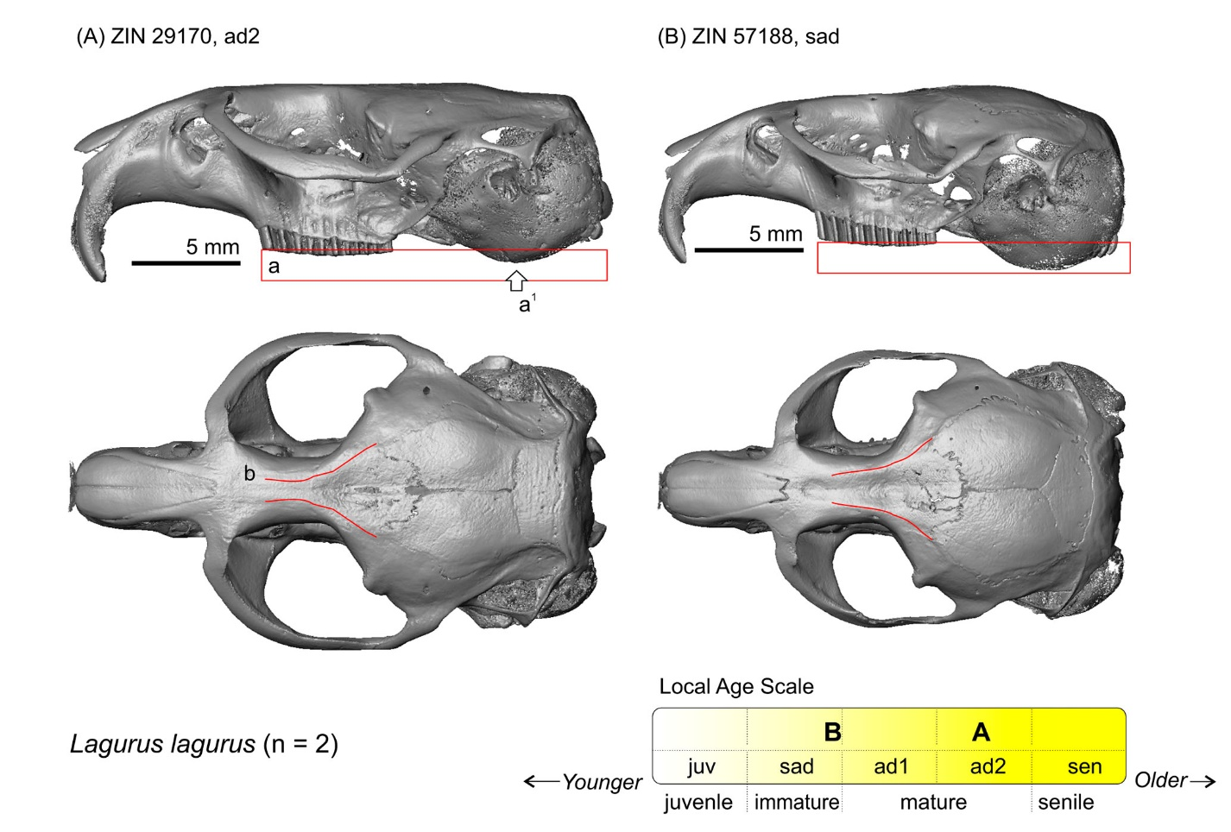

**Figure S17**. Relative age groups of the analysed specimens of *Lasiopodomys brandtii*: (A) ZIN 82110; (B) ZIN 82114.

Skulls are shown in lateral (top) and dorsal (bottom) view. Scale bars are 5 mm; skulls are shown at the same scale. *Key*: **a**, the temporal line in the mature specimen.

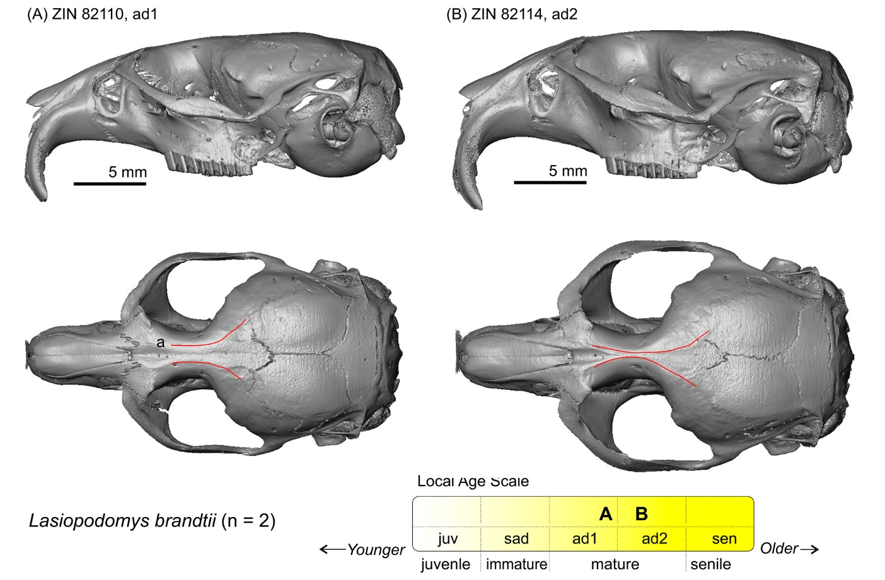

**Figure S18**. Relative age groups of the analysed specimens of *Lasiopodomys gregalis*: (A) ZIN 15332; (B) ZIN 53120; (C) ZIN 96293; (D) ZIN 103094.

Skulls are shown in lateral (top) and dorsal (bottom) views. Scale bars are 5 mm; skulls are shown at the same scale. *Key*: **a**, line with arrows 'a1–a2' marks differences between mature and immature specimens; **b**, frame with arrow 'b1' marks differences in relative position of teeth and tympanic bulla levels between mature and immature specimens; **c**, temporal line.

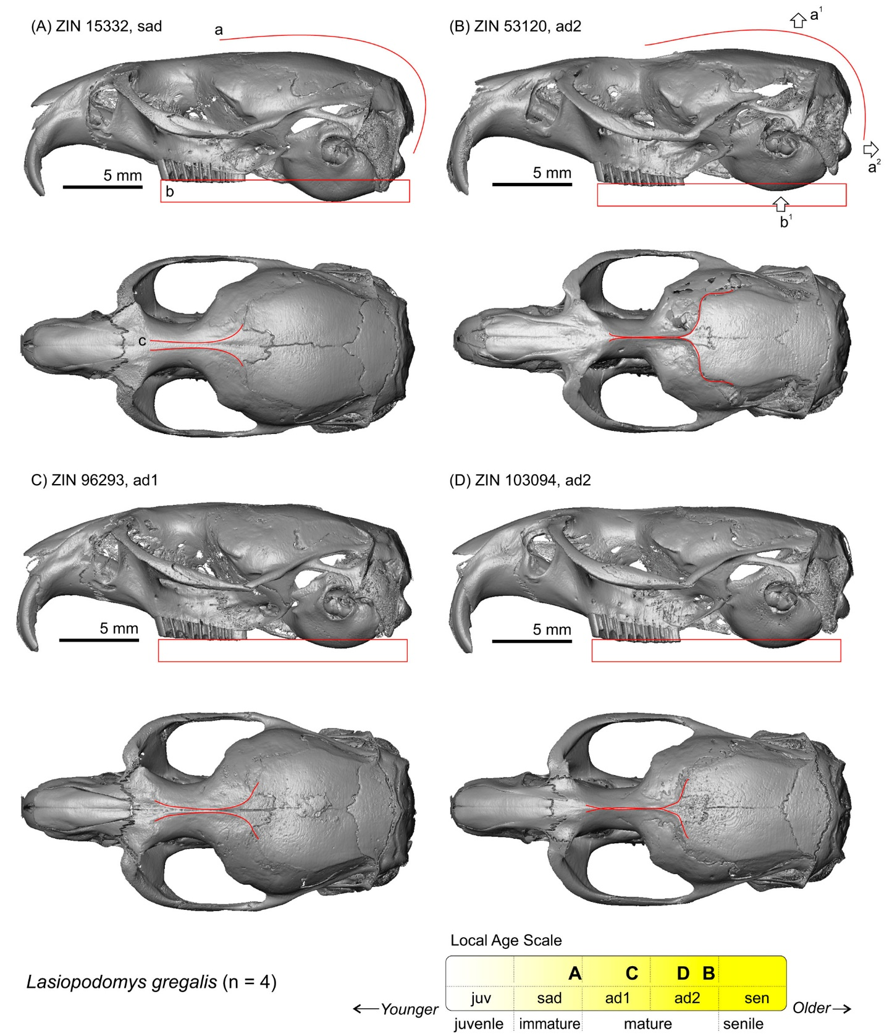

**Figure S19**. Relative age groups of the analysed specimens of *Lasiopodomys mandarinus*: (A) ZIN 78327; (B) ZIN 78614.

Skulls are shown in lateral (top) and dorsal (bottom) views. Scale bars are 5 mm; skulls are shown at the same scale. The age group was determined with the aid of *L. brandtii* age attribution (see Fig. S17).

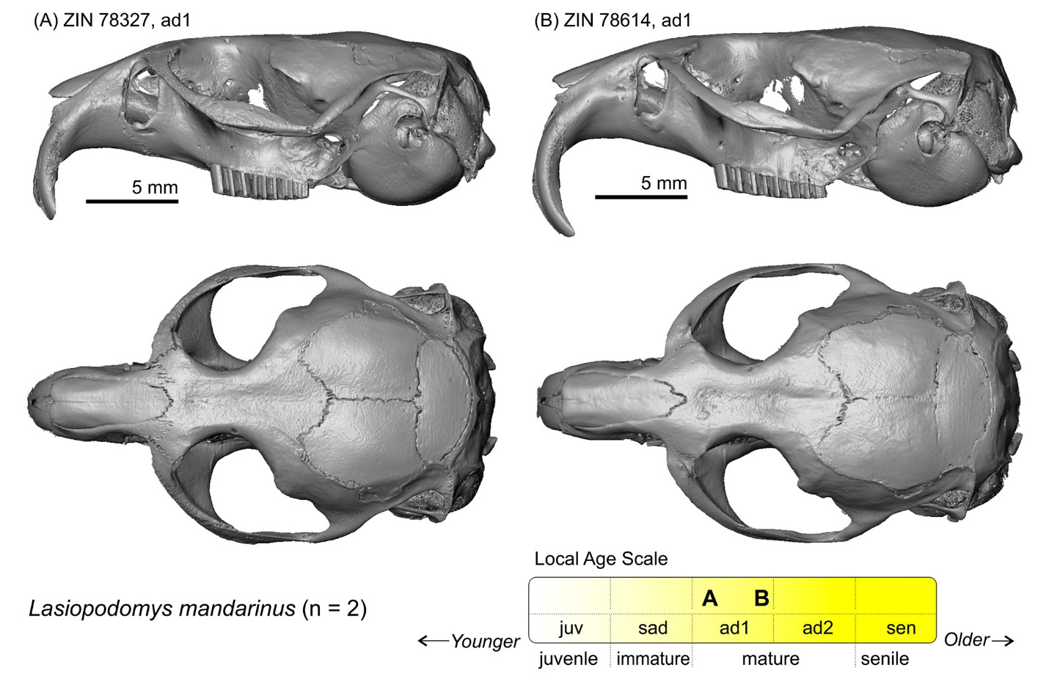

**Figure S20**. Relative age groups of the analysed specimens of *Lasiopodomys raddei*: (A) ZIN 101665 (B) ZIN 105338; (C) ZIN 105341; (D) ZIN 105344.

Skulls are shown in lateral (top) and dorsal (bottom) views. Scale bars are 5 mm; skulls are shown at the same scale. The age group was determined with the aid of *L. gregalis* age attribution (see Fig. S18). *Key*: **a**, line with arrows 'a1–a2' marks differences between mature and immature specimens; **b**, frame with arrow 'b1' marks differences in relative position of teeth and tympanic bulla levels between mature and immature specimens; **c**, temporal line.

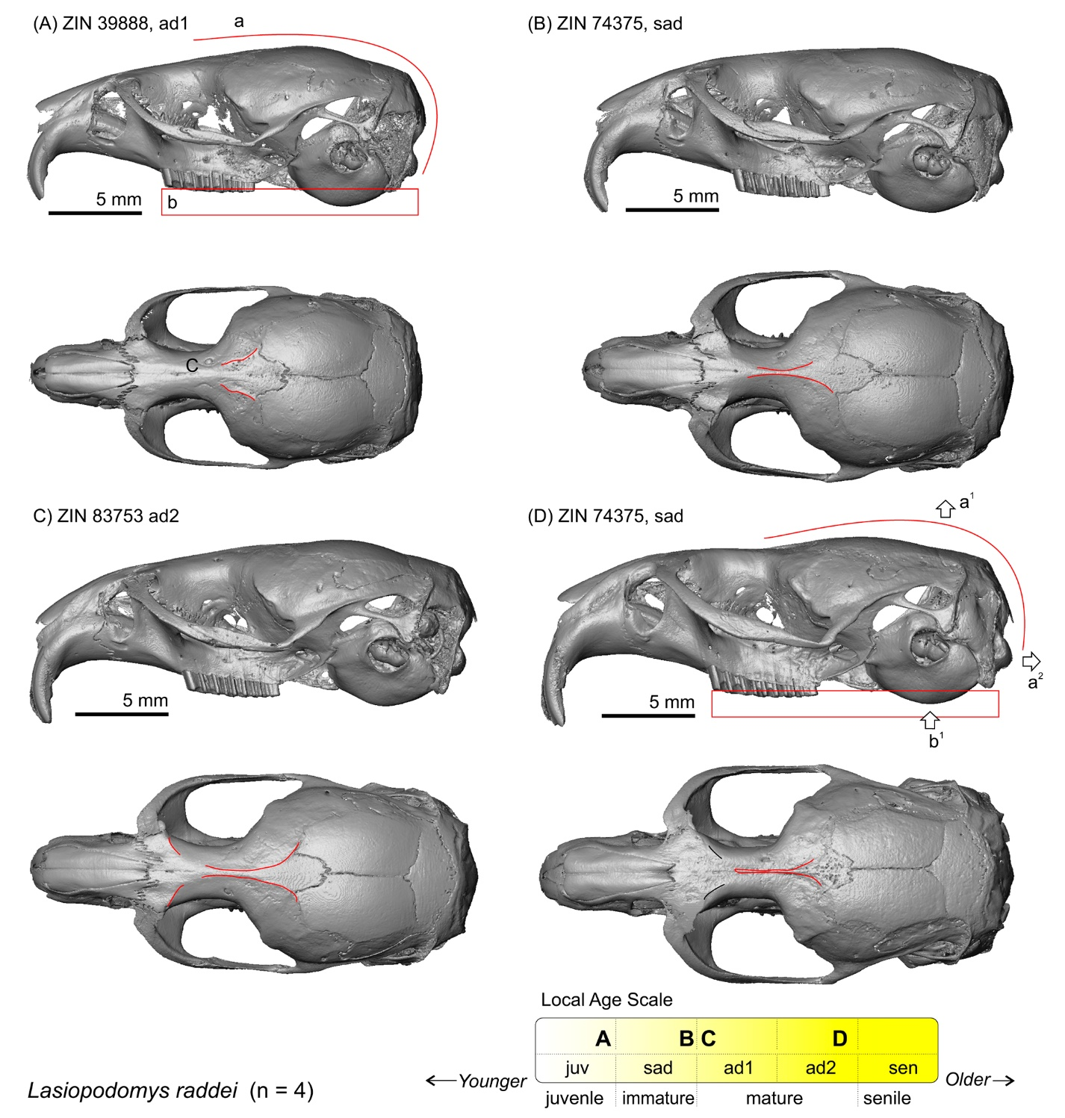

**Figure S21**. Relative age groups of the analysed specimens of *Lemmus sibiricus*: (A) ZIN 64159; (B) ZIN 81239; (C) ZIN 81241.

Skulls are shown in lateral (top) and dorsal (bottom) views. Scale bars are 5 mm; skulls are shown at the same scale. The age group was determined with the aid of *M. schisticolor* age attribution (see Fig. S30 below).

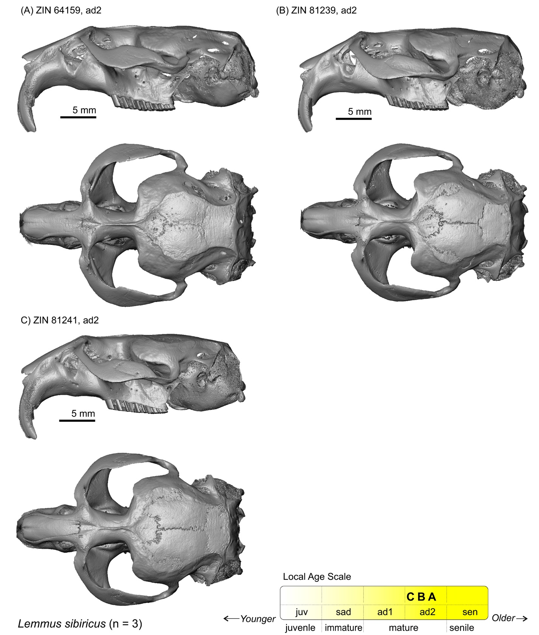

**Figure S22**. Relative age groups of the analysed specimens of *Microtus arvalis*: (A) ZIN 19431; (B) ZIN 56750 (neotype).

Skulls are shown in lateral (top) and dorsal (bottom) view. Scale bars are 5 mm; skulls are shown at the same scale. *Key*: **a**, the temporal line in the mature specimen.

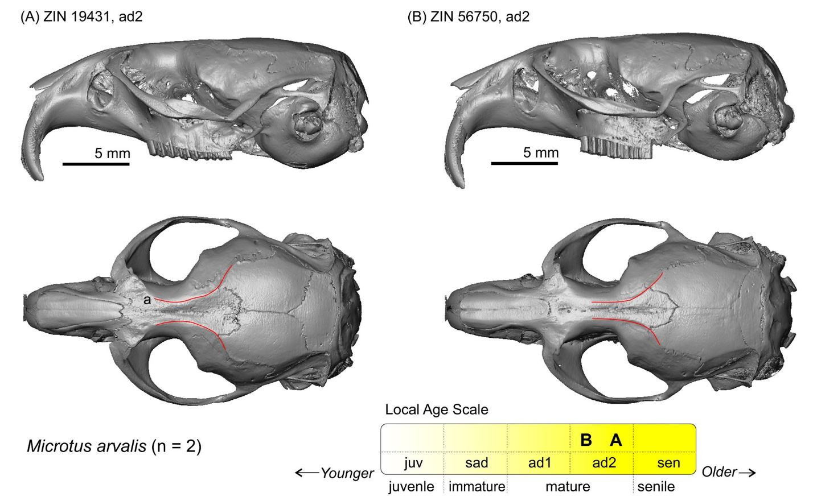

**Figure S23**. Screenshots of the PSP complex in subposterior view of specimen ZIN 78436 of *Mynomes miurus* with landmark positions (left). Skull in lateral (top, right) and dorsal (bottom, right) view.

Scale bar is 5 mm. The age group was determined with the aid of *L. gregalis* age attribution (see Fig. S18).

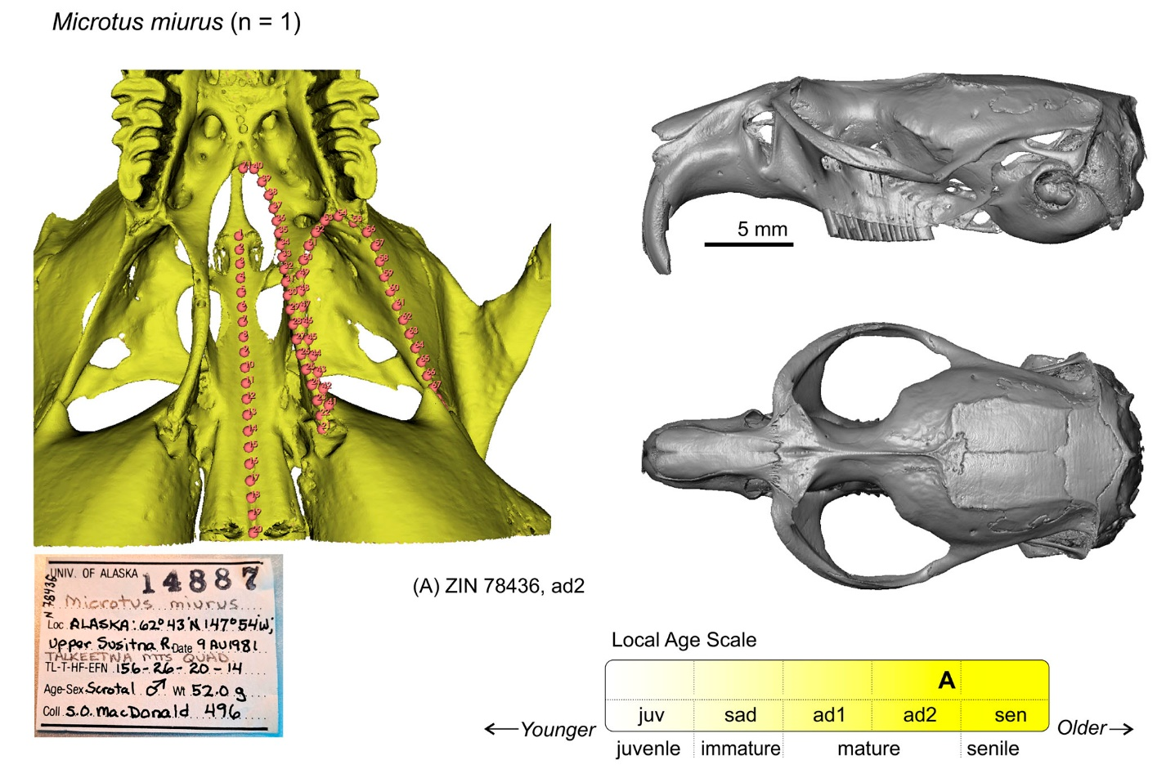

**Figure S24**. Screenshots of the PSP complex in subposterior view of specimen ZIN 40410 of *Mynomes ochrogaster* with landmark positions (left). Skull in lateral (top, right) and dorsal (bottom, right) view.

Scale bar is 5 mm. The age group was determined with the aid of *A. fortis* age attribution (see Fig. S2).

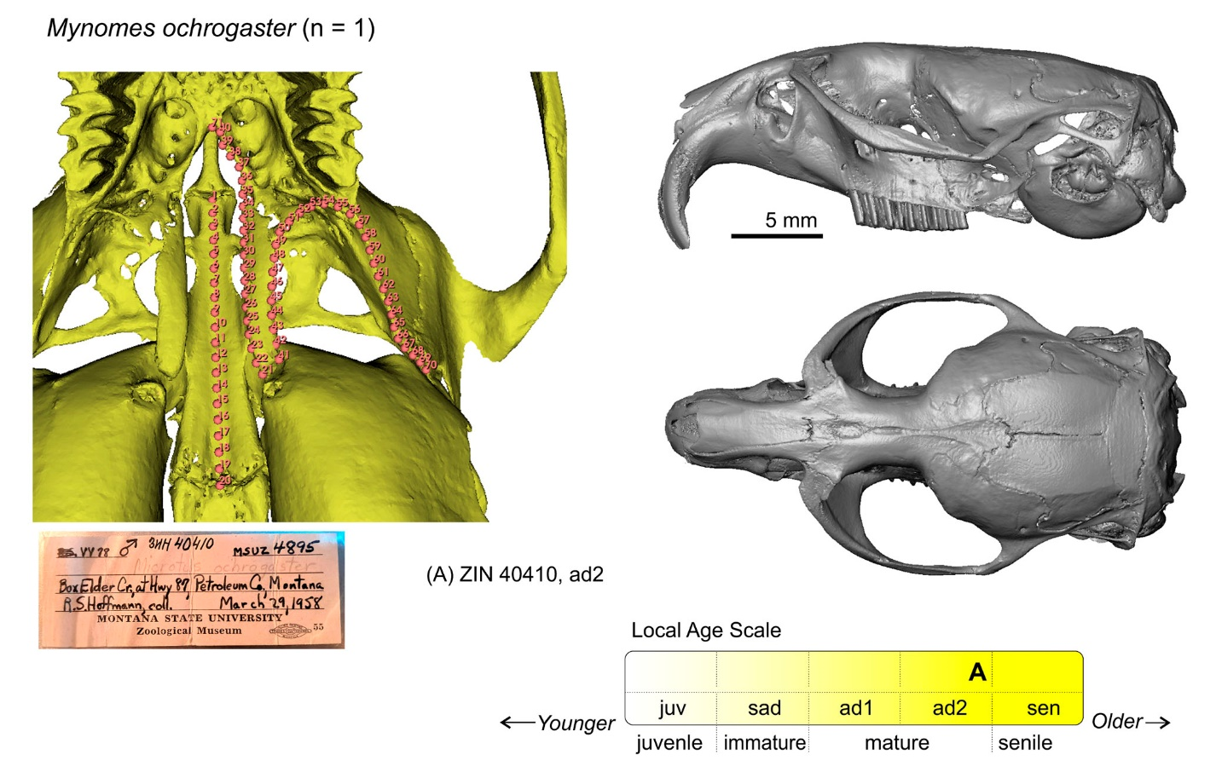

**Figure S25**. Relative age groups of the analysed specimens of *Mynomes pennsylvanicus*: (A) ZIN 39888 (B) ZIN 74351; (C) ZIN 83753(6951).

Skulls are shown in lateral (top) and dorsal (bottom) views. Scale bars are 5 mm; skulls are shown at the same scale. *Key*: **a**, temporal line.

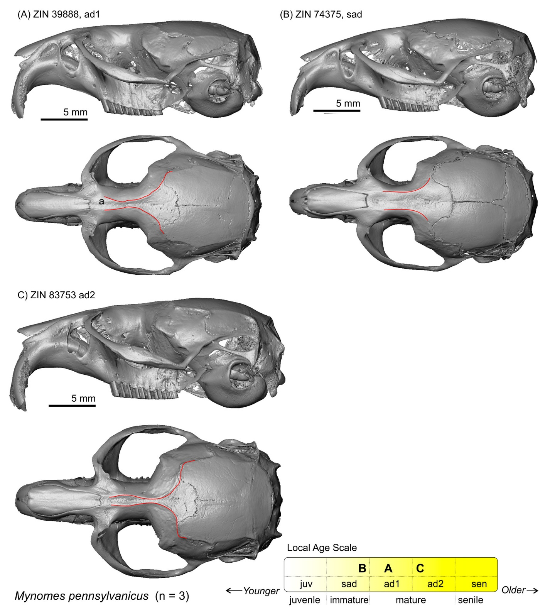

**Figure S26**. Screenshots of the PSP complex in subposterior view of specimen ZIN 40412 of *Mynomes richardsoni* with landmark positions (left). Skull in lateral (top, right) and dorsal (bottom, right) view.

Scale bar is 5 mm. The age group was determined with the aid of *A. fortis* age attribution (see Fig. S2).

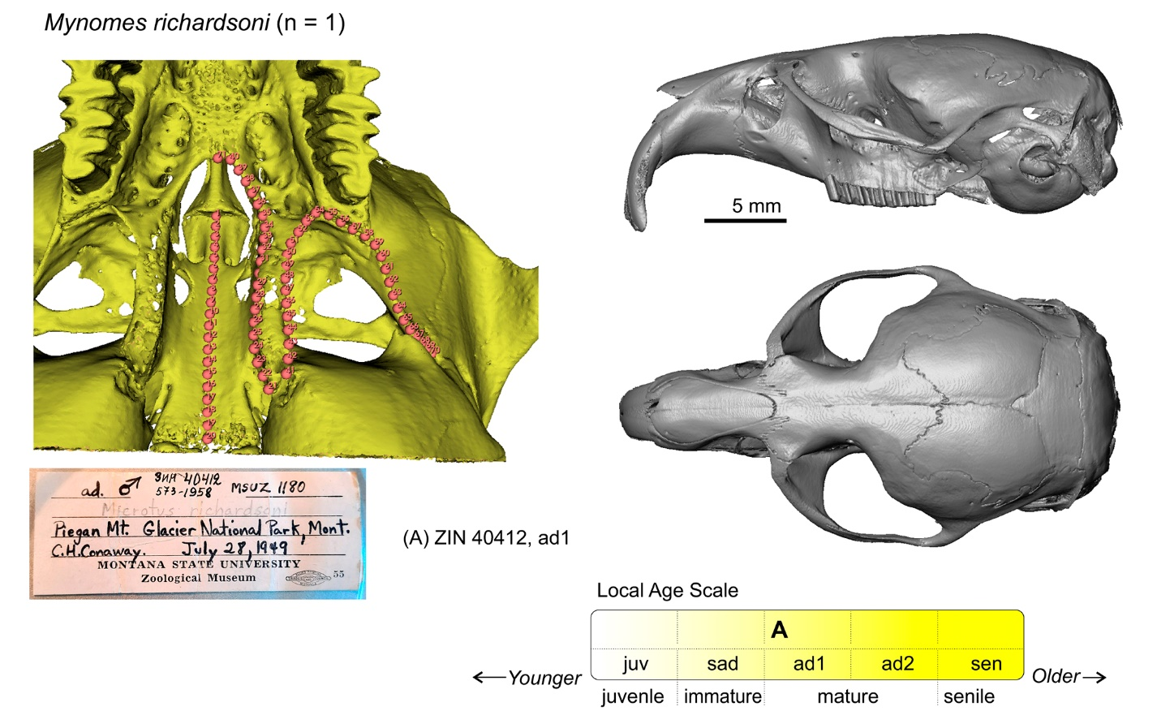

**Figure S27**. Relative age groups of the analysed specimens of *Myodes centralis*: (A) ZIN 21254; (B) ZIN 107137.

Skulls are shown in lateral (top) and dorsal (middle) views. The lower images show lateral radiographs of molar roots (root-bearing species only). Scale bars are 5 mm; skulls are shown at the same scale. *Key*: **a**, the temporal line.

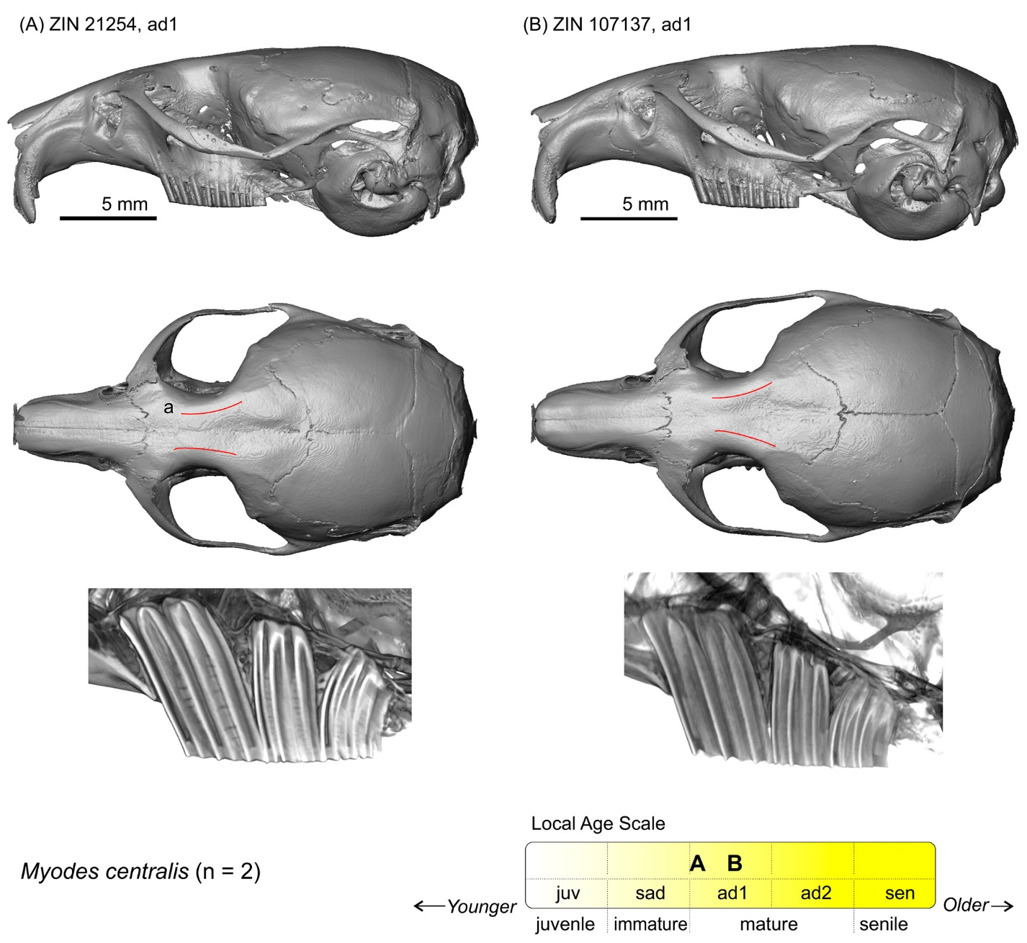

**Figure S28**. Screenshots of the PSP complex in subposterior view of specimen ZIN 106573 of *Myodes glareolus* with landmark positions (left). Skull in lateral (top, right) and dorsal (middle, right) view.

The lower image shows lateral radiograph of molar roots (root-bearing species only). Scale bar is 5 mm.

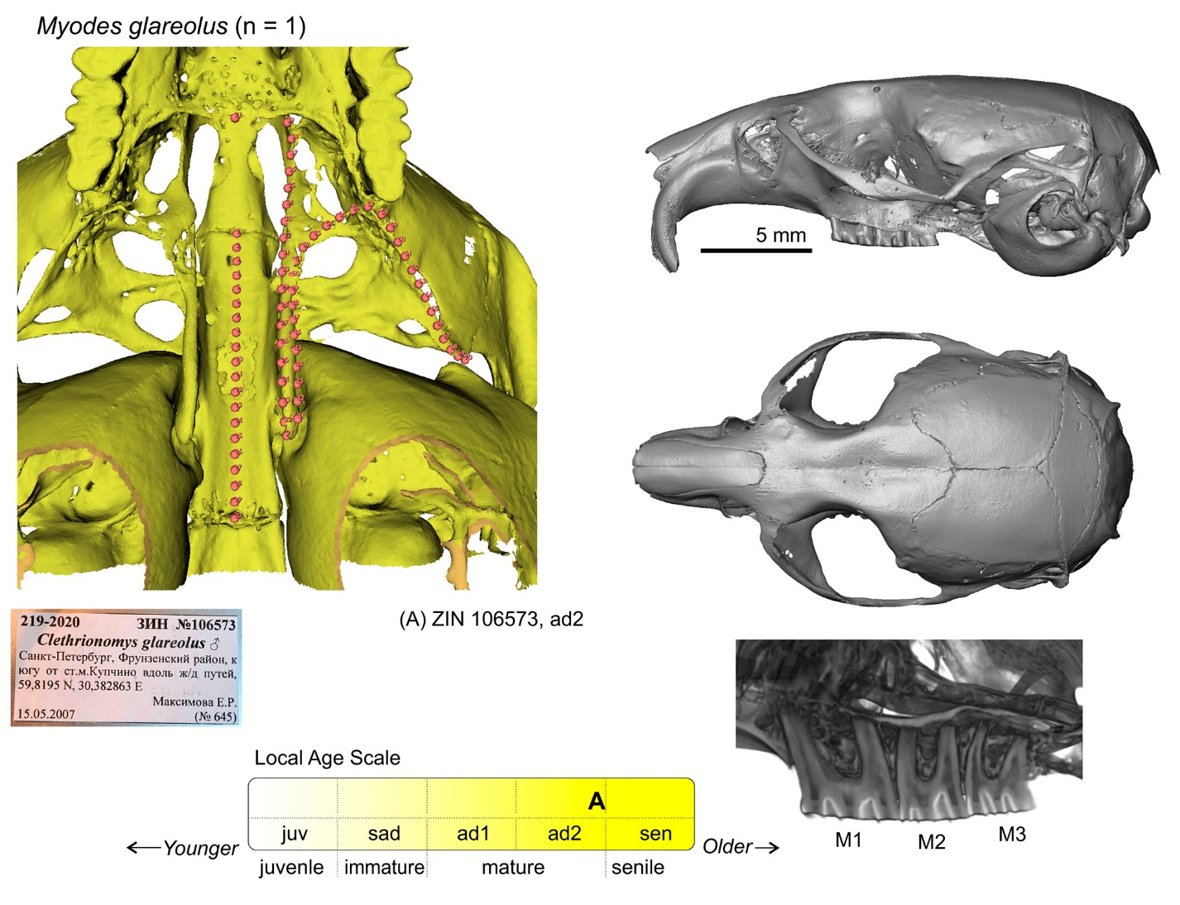

**Figure S29**. Relative age groups of the analysed specimens of *Myodes rutilus*: (A) ZIN 20967; (B) ZIN 20974; (C) ZIN 20978; (D) ZIN 20984.

Skulls are shown in lateral (top) and dorsal (bottom) views. (E1–E4) Lateral radiographs of molar roots (root-bearing species only). Scale bars are 5 mm; skulls are shown at the same scale.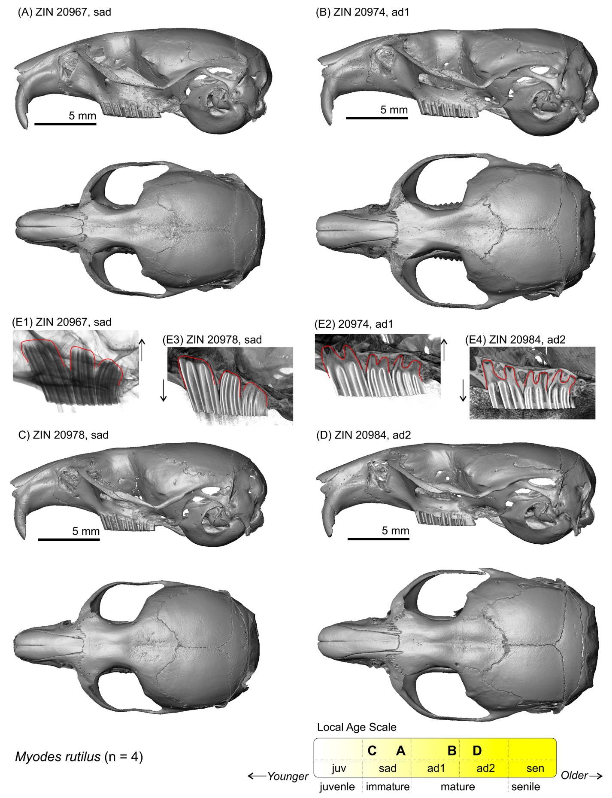

**Figure S30**. Relative age groups of the analysed specimens of *Myopus schisticolor*: (A) ZIN 100554; (B) ZIN 103730.

Skulls are shown in lateral (top) and dorsal (bottom) views. Scale bars are 5 mm; skulls are shown at the same scale. *Key*: **a**, the temporal line.

